Exercise: Basic Linux & Bash commands

- *I have installed The Windows Subsystem for Linux (WSL) and open it from PowerShell with command: wsl*

1.Create a file friends.txt with a list of names of three of your friends on separate lines.

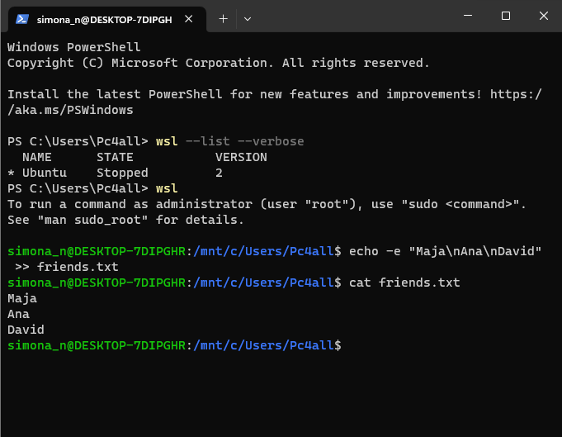

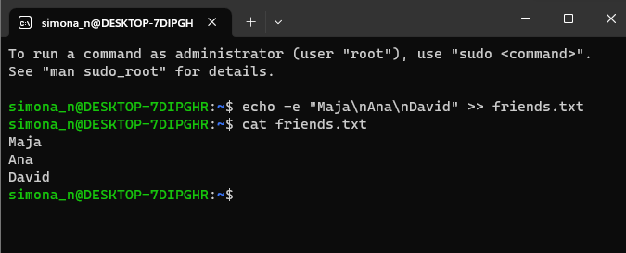

In the second picture the commands are written directly in ubuntu

The ‘**-e**‘ option in Linux acts as an interpretation of escaped characters that are backslashed

Using option ‘**\n**‘ – New line with backspace interpretor ‘**-e**‘ treats new line from where it is used

2.Display the contents of friends.txt on the console.

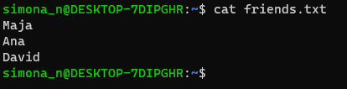

3.Rename file friends.txt to bestfriends.txt



4.Make a copy of bestfriends.txt under the name sysadmins.txt



5.List all files whose name begins with letter 'b' and ends with extension txt.

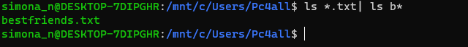

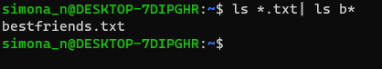

In the second picture the commands are written directly in ubuntu, I didn’t opened first PowerShell, than wsl (the result is the same)

6.Write a command that will tell you how many bytes are taken up by file sysadmins.txt

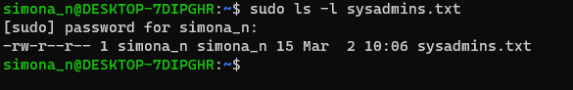

7.Create file cars.txt with a list of 5 brands of cars on separate lines.

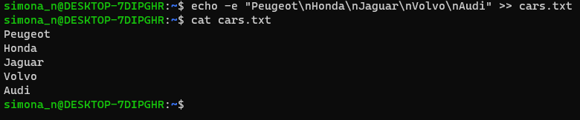

8.Check how many bytes are taken up by the file.



-c prints the byte count

9.Copy the file cars.txt into directory /tmp



10.List all files with extension *.txt in directory /tmp and verify that the file was copied properly.



11.Without leaving your home directory rename file cars.txt located in /tmp to vehicles.txt in /tmp

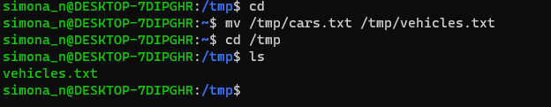

12.Display the contents of /etc/passwd file on the screen interactively (so you can search, scroll up and down)

